

**Telecommunication Customers Churn Analysis**

**By**

**Zhi Ji and Spencer Young**

**Dec 18, 2020**

**____________________________________________________________________________**

**Final Project**

**Intro to Business Analytics**

### **D'Amore-McKim School of Business**

**Northeastern University**

**Abstract**

The telecommunication industry is the cornerstone for today's fast-paced lifestyle, it has boosted the efficiency of information transfer, making it become essential in modern people's life. Whether in a household or business, telecommunication services are a priority, especially in 2020. The telecommunication industry is an integral part of the economy as the global telecom industry market size was valued at approximately $1.75 trillion USD in 2019 (Grand View Research, 2019). During the past year, COVID-19 has locked most people at home, making people more dependent on telecommunications services than ever before. Now, in this era of the telecommunication industry, customer retention ability could become one of the key drivers to success, and our analysis will help to answer the following questions: "what is happening", "why should people care", and "what to do next".

**Table of Contents**

**Part 1: What Is Happening**

1.1 Current Situation

**Part 2: Why Should Companies Care**

2.1 Customer Lifetime Value

2.2 Other Potential Benefits

**Part 3: What to Focus On**

3.1 Data Introduction & Exploration

3.2 Modeling

3.2.1 Regression Analysis

3.2.2 Classification Analysis

3.3 Other Factors

**Part 4: How to Solve**

4.1 Managerial Recommendation

**Part 5: Appendix**

5.1 Correlation Test

5.2 Support Vector Machine Model

5.3 Decision Tree Model

**Part 6: References**

**Part 1: What Is Happening**

**1.1 Current Situation**

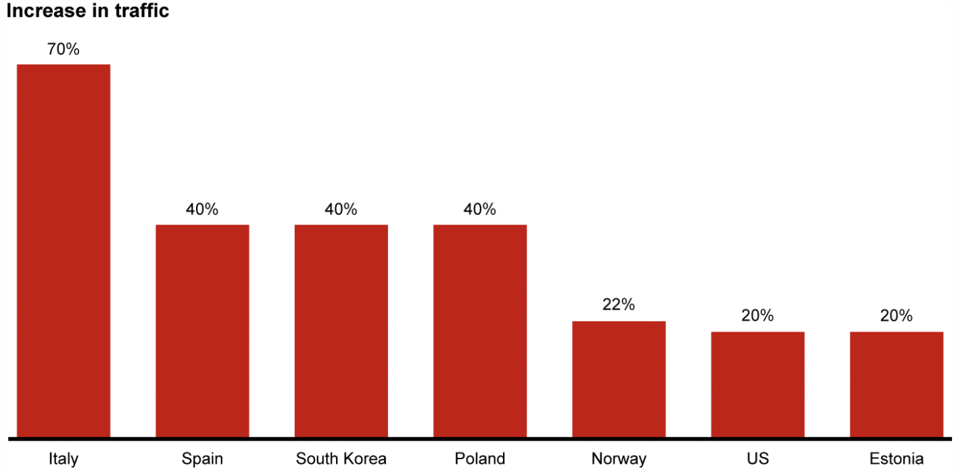

Figure 1: Increase in network traffic among different countries during COVID-19

The current state of affairs that have been catalyzed by COVID-19 has affected every facet of daily life, consequently all industries have had to adapt. The economy has been severely damaged from the pandemic as businesses are closing daily and consequently millions of people are losing their jobs. As of December 2020, the unemployment rate in the United States is 6.7% (U.S Department of Labor, 2020). However, the pandemic boosted the demand of telecom services. Figure 1 shows the increase in telecommunication traffic in different parts of the world. In detail, the churn rate among the top telecommunication companies in the U.S. has increased from 35% to 41% within one year (Westcott and Arbanas, 2020), and nearly 80% of consumers now retract their loyalty faster than they did three years ago (Mort, 2020).

**Part 2: Why Should Companies Care**

**2.1 Customer Lifetime Value**

Today, companies in their own industries are fighting against each other, trying to expand their territories, competing for customers. Indeed, customers are the key to profitability, and many firms are working harder than ever to obtain new customers. However, lots of clients ended up disappointed with either their products or services and left the company in a very short time. That is, most companies have failed to see the potential of their customers' lifetime value. According to an article from Harvard Business School, companies can boost profits by a shockingly 100% by keeping 5% more of their customers, and sometimes it can even compete with cost leadership strategy (Reichheld and Sasser, 2014), and more importantly, the loyal customers are willing to pay premium prices since they valued a company’s products and services.

Customer retention programs could be even more urgent in the telecommunication industry. According to research from NYU, the average customer lifetime is 52 months, and most of the churn happens at the 19th month, causing the companies to lose over $1100 for each churned customer. This leads us to an astonishing result, each of the top four carriers (AT&T, Verizon, T-Mobile, Sprint) in the U.S. lost approximately $65 million per month from churned customers.

**2.2 Other Potential Benefits**

Although the truth is that most parts of the customers’ lifetime value remain untapped, many of the companies are still trying to spend far more than enough amounts of money on commercial advertisement but ignoring their customers’ demands: 75% of online customers expect help within 5 minutes; 60% of U.S. consumers are concerned about the privacy of online transactions; 70% of app users prefer functionality over the “look and feel” of the app (McKinsey & Co., 2020), finally making a customer be even more likely to defect.

Customers are a free double-edged sword advertisement that can be both beneficial and catastrophic for a company. According to a survey, nearly 80% of customers had experienced disappointment on their telecommunication services, with most of them sharing their bad experiences with friends and family (TechSee, 2020). Combining with the truth that 92% of customers in the industry trust personal recommendations and online reviews when choosing their service providers (DCR Strategy, 2020). Thus, those retained customers will easily become a free rapidly-spreading flyers and those churned customers will take their potential values and friends to your rivals.

Retaining a customer can not only save the operational expenses for a company, but will also boosts its productivity. The reason for that is as a customer is retained in a company for longer, the company will know the demand of that customer better, and the customer will know the capability of the company better as well (Reichheld and Sasser, 2014). That is, retaining a customer can eliminate the series of exhausting processes of gaining a new customer while simultaneously saving time and money for an organization.

**Part 3: What to Focus**

**3.1 Data Introduction & Exploration**

In this section, we’ll be using an up-to-date dataset “Telco Customer Churn” from Kaggle.com to discover more insights that could be helpful in identifying churning customers. The dataset itself contains 7043 individual churn cases and 20 customer features that can be broken down into 3 categories:

|  |  |
| --- | --- |
| **Feature Category** | **Features** |
| Customer Features | Customer ID, Gender, Senior Citizen, Partner, Dependents, Tenure |
| Services Selected | Phone Service, Multiple Lines, Internet Service, Online Security, Online Backup, Device Protection, Tech Support, Streaming TV, Streaming Movies |
| Payment Method | Contract, Paperless Billing, Payment Method, Monthly Charge, Total Charge |

The target variable is “Churn”, which has two levels to indicate whether a customer churned or not. After the data preparation, we built and tuned the linear regression model, SVM model, and decision tree model, we also used a training (80%) and testing (20%) set.

**3.2 Modeling**

**3.2.1 Regression Analysis**

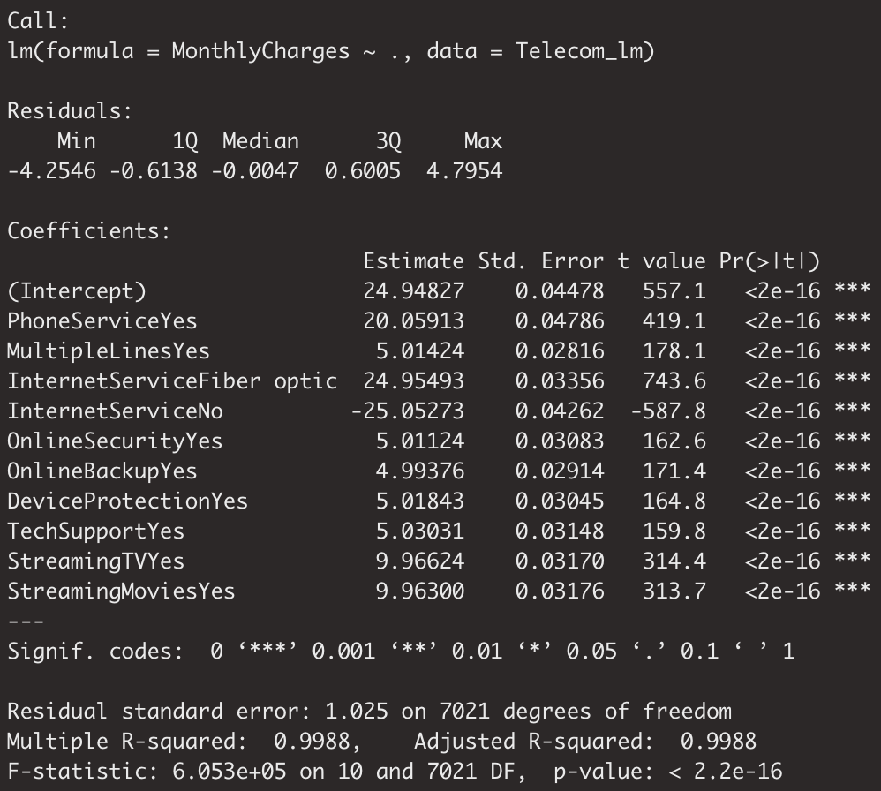

Figure 2: Linear Regression Model Output

Since telecommunication customers are sensitive to the pricing strategy, we constructed a linear regression model to figure out the key drivers of customers’ monthly charges. we first set the “MonthlyCharges” as the dependent variable and noticed that the phone service and internet service are key determinates of the monthly charges. All individual variables and the entire model are significant with R^2 equals to 0.9988, meaning that 99.88% of the sample variability in the data set is explained by the model.

**3.2.2 Classification Analysis**

In this section, we constructed an SVM and decision tree model. After doing model evaluation, the decision tree model outperformed the SVM model. (More model details are in Appendix). Decision Tree model was known for its convenience of interpretation when compared with the decision boundaries in the SVM model. Moreover, the decision tree model has both the highest accuracy and recall, and the recall score is typically important since we cannot tolerate type II error cases.

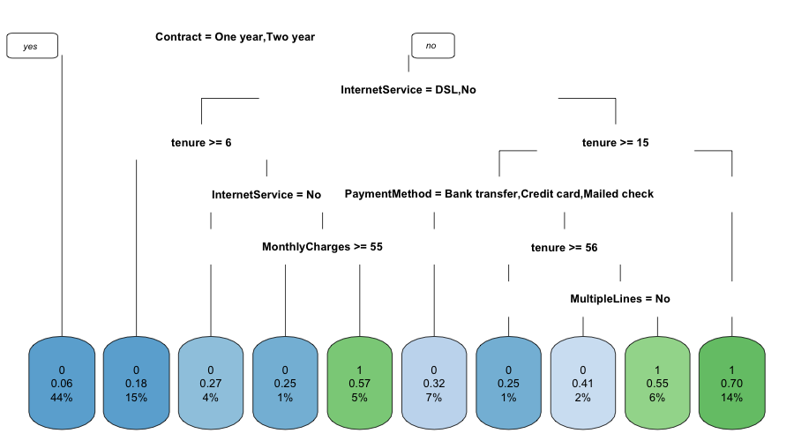

Figure 3: Decision Tree Output

From the output of the decision tree model, there are 3 types of customers that need attention from a telecommunication company:

1. A customer that has “Month-to-Month" contract, selects “Fiber optic” service, also his or her “tenure” less than 15.
2. A customer that has “Month-to-Month" contract, selects “Fiber optic” service, “tenure” is greater than or equal to 15, uses “Electronic check” as payment method, “tenure” is less than 56, also choose “MultipeLines”.
3. A customer that has “Month-to-Month" contract, selects “No” or “DSL” as his or her internet service, “tenure” less than 6, has “Internet Service”, and “MonthlyCharges” less than 55.

**3.3 Other Factors**

Beyond what has been discovered in the dataset, there are a few more reasons for churn in the telecommunication industry. A survey to those churned customers conducts that over 50% call more than once to solve their problems, and near 40% deemed the representatives as unprofessional (TechSee, 2020). Thus, the low efficiency in solving customers’ problems combined with the unprepared customer service fleet is deadly to the organizations in this industry. Moreover, because of low differentiation between services and the low cost of switching service providers (simconblog, 2016), people are sensitive to the pricing and thus a small mistake in pricing and billing can easily destroy customers’ loyalty to a company (Spotfire Team, 2019).

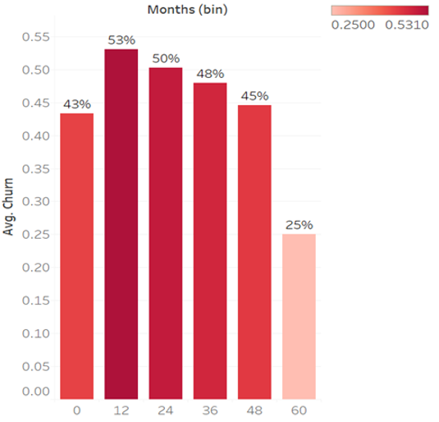

Figure 4: Rate of Churn by Time

Figure 4, from Aditya’s research, uncovered the truth that most of the churn cases happened within the first year, which also supports our decision tree output, and the possibility of churn dropped the longer customers stayed with the company. Thus, analyzing what happened on those churned customers during the first year could be useful in uncovering the mistakes a company made.

**Part 4: How to Solve**

**4.1 Managerial Recommendation**

For companies in the telecommunication industry to not only survive during these arduous times, but thrive, strategies must be put in place to create customer satisfaction and retention. First, we recommend that providers learn how consumer needs and behaviors have changed in the last few years, especially in 2020. A possible action to be taken in identifying these changes is providing questionnaires to customers that ask what they currently prioritize in a telecommunication service. By understanding how customers' needs and priorities have changed providers can tailor their services to their consumer bases respective needs, therefore increasing customer satisfaction. Satisfying customers' needs has the potential to preemptively eliminate the various human resources problems that we found customers most often complain about. Second, companies need to emphasize a productive and professional human resources team. Our findings suggest that most customers churn because of a displeasure with the human resources team of their respective provider; service is paramount for a company in the telecommunication industry to succeed; customers need to feel like they are a priority and are valued. Hiring people who are personable, patient and articulate to represent their customer service teams should be emphasized by leadership. This process starts at the hiring phase, case studies should be given to candidates to assess their problem-solving skills and patience. Third, companies need to continue to identify the “why” in catching and retaining customers. Through an understanding of why customers are unsatisfied with their service and eventually churn, they can improve customer retention. Companies need to be continuously collecting churn data that enable them to learn from their past and present mistakes.

**Part 5: Appendix**

**5.1 Correlation Test**

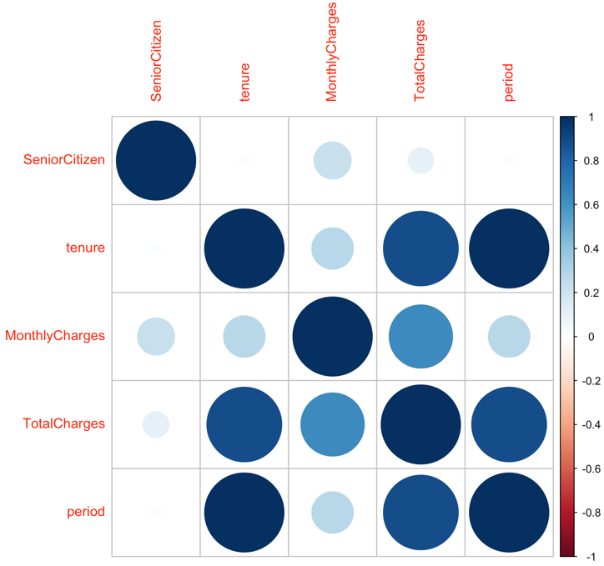

Parameters in used:

* + Method = Spearman

**5.2 Support Vector Machine Model**

Parameters in used:

* Model tunning: function = tune.svm(), kernel = "radial", cost = 10^(-3:1), gamma = 10^(-5:-1).
* Optimal Parameters: kernel = "radial", cost = 10, gamma = 0.001

Confusion matrix:

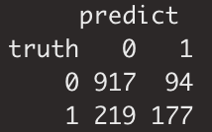

accuracy = 0.7754, precision = 0.6531, recall = 0.4470.

**5.3 Decision Tree Model**

Parameters in used: minsplit = 9, minbucket = 0.5, maxdepth = 6, cp=0.005

Confusion matrix:

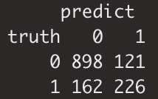

accuracy = 0.7989, precision = 0.6513, and recall = 0.5825.

**References**

Figure 1: Bhak, Alex, et al. “Telcos and Coronavirus: Three Steps to Manage the Crisis.” Bain, 4 Dec. 2020, [www.bain.com/insights/telcos-and-coronavirus-three-steps-to-manage-the-crisis/](http://www.bain.com/insights/telcos-and-coronavirus-three-steps-to-manage-the-crisis/).

Figure 4: KAPOOR, ADITYA. “CHURN IN THE TELECOM INDUSTRY – IDENTIFYING CUSTOMERS LIKELY TO CHURN AND HOW TO RETAIN THEM.” Aditya Kapoor, 17 Feb. 2017, wp.nyu.edu/adityakapoor/2017/02/17/churn-in-the-telecom-industry-identifying-customers-likely-to-churn-and-how-to-retain-them/.

Westcott, Kevin, and Jana Arbanas. “2021 Telecommunications Industry Outlook.” Deloitte United States, 10 Dec. 2020, www2.deloitte.com/us/en/pages/technology-media-and-telecommunications/articles/telecommunications-industry-outlook.html.

Mort, Andrew. “Top Customer Retention Strategies in the Telecom Industry.” TechSee, 19 Apr. 2020, techsee.me/blog/telecom-customer-retention/.

Reichheld, Frederick F., and W. Earl Sasser. “Zero Defections: Quality Comes to Services.” *Harvard Business Review*, 1 Aug. 2014, hbr.org/1990/09/zero-defections-quality-comes-to-services.

Ehrlich, Oliver, et al. “Mastering the Digital Advantage in Transforming Customer Experience.” *McKinsey & Company*, McKinsey & Company, 20 Oct. 2020, [www.mckinsey.com/business-functions/operations/our-insights/mastering-the-digital-advantage-in-transforming-customer-experience](http://www.mckinsey.com/business-functions/operations/our-insights/mastering-the-digital-advantage-in-transforming-customer-experience).

Unemployment Rates for States. (2020, November 20). Retrieved December 17, 2020, from https://www.bls.gov/web/laus/laumstrk.htm

Global Telecom Services Market Size &amp; Share Report, 2020-2027. (n.d.). Retrieved December 17, 2020, from [https://www.grandviewresearch.com/industry- analysis/global-](https://www.grandviewresearch.com/industry-%20%20%20%20%20%20%20%20%20%20%20%20%20%20%20%20%20%20%20%20%20%20%20%20%20analysis/global-) telecom-services-market

Group, TechSee. “Reasons for Customer Churn in Telecoms [Survey Results].” TechSee, 11 May 2020, techsee.me/resources/surveys/2019-telecom-churn-survey/.

Dcrstrategies.com. “5 Reasons Why Customer Retention Is Key To Your Business.” DCR Strategies Inc, 2 Sept. 2020, [www.dcrstrategies.com/customer-incentives/5-reasons-customer-retention-business/](http://www.dcrstrategies.com/customer-incentives/5-reasons-customer-retention-business/).

Spotfire Blogging Team. “Data Analysis to Reduce Churn in Telecom.” The TIBCO Blog, 15 Mar. 2019, [www.tibco.com/blog/2013/04/10/data-analysis-to-reduce-churn-in-telecom/](http://www.tibco.com/blog/2013/04/10/data-analysis-to-reduce-churn-in-telecom/).

Simconblog. “Telecommunications Industry Analysis.” SIMCON Blog, 18 June 2016, simconblog.wordpress.com/2016/06/18/telecommunications-industry-analysis/.